Name: Chey Naryvety
ID: IDTB110199
LAP5

Lab01-02
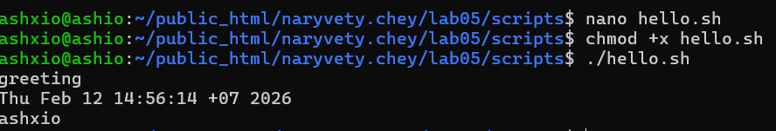
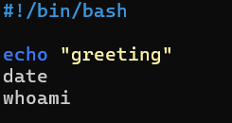
use vim or nano to write into the script created
Lab03
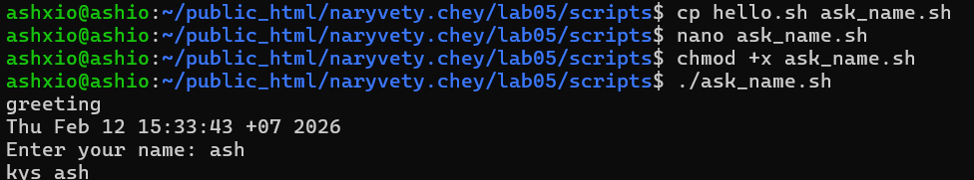
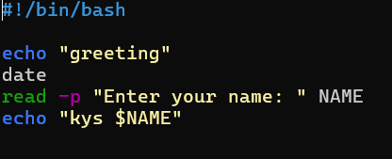
Use $ to get result from the command input and print

Lab04
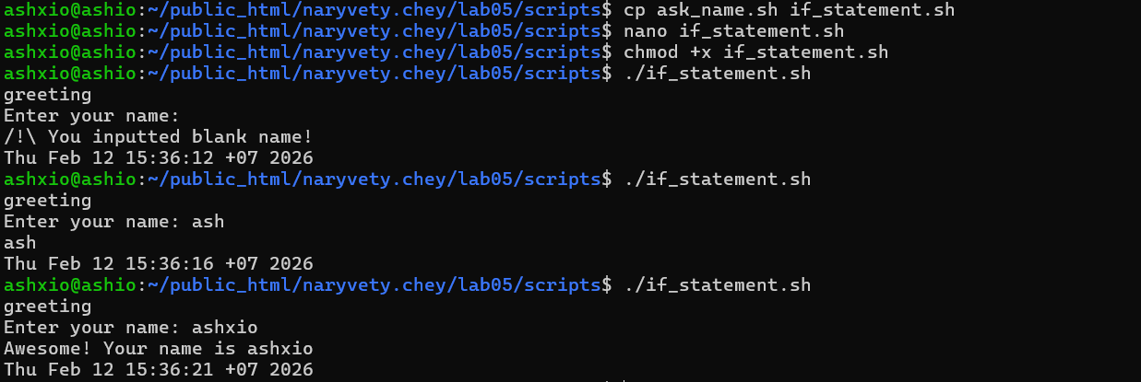
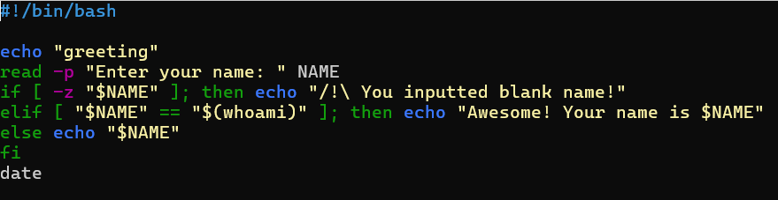
Use if else and must pay attention to syntax or else it wont work. Use -z to check empty string
Assignment W05-1
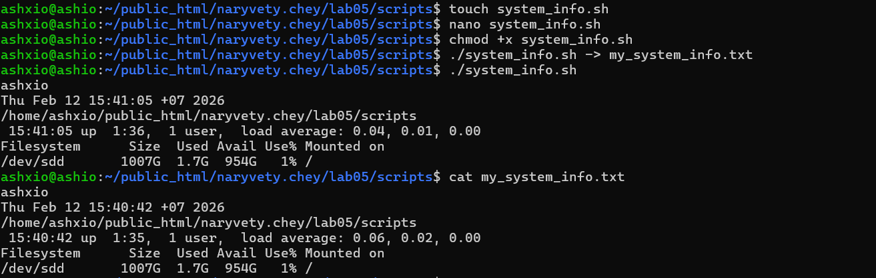
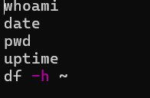
Use -> to overwrite result into another file

